

**11219 Financial Centre Parkway Phone: 501-725-0830**

**Suite 240 Fax: 501-725-0825**

**Little Rock, Arkansas 72211**

Dear Patient,

Welcome to Chenal Pain Management. We appreciate the confidence and trust you have placed in us by scheduling an appointment and we look forward to seeing you. Please arrive 30 minutes prior to your scheduled appointment time. The philosophy of our practice is to best help you manage your chronic or current pain symptoms. We shall make every effort to see that your experience with our clinic is as comfortable as possible.

At your initial appointment, Dr Prasad will take a complete history. Please provide our office with copies of any reports from previous tests such as MRI, CT, EMG, bone scans, X-Rays and any other diagnostic testing that has been done for your current problem. The doctor needs this information to assist in your treatment.

**We ask that you bring a copy of your insurance cards & drivers license and be prepared to pay your copay at time of check in.** We will make every effort to maintain our schedule and yours. If you are unable to keep your appointment we ask that you give us at least 48 hours notice.

We will be happy to discuss anything with you in an open manner and welcome any questions or concerns you may have. **We look forward to seeing you in our clinic!**

Sincerely,

Dr Krishnappa Prasad, MD



**11219 Financial Centre Parkway Phone: 501-725-0830**

**Suite 240 Fax: 501-725-0825**

**Little Rock, Arkansas 72211**

**Personal Information:**

Patient Name:_________________________________ Date of Birth:____/____/______

Mailing Address:_________________________________________________________

City:_________________ State:_______ Zip Code:___________

Cellphone:_____-______-__________ Work Number:_____-______-__________

Social Security #:______-______-______ Sex:___________ Marital Status: _________

Email Address:__________________________________@________.com

Additional Contact Number:_____-______-__________ Relationship:_______________

Family Physician:____________________ Contact Number:_____-______-__________

**Employer Information:**

Employer:_________________________________

Employer Address:__________________________City:__________

Employer Phone Number: _____-______-__________

**Reason for New Patient Consult:**

Is your pain…

Work Related ( )

Car Accident ( )

Other Accident ( ) If other, please explain:___________________________________

**Insurance Information and Co-payments:**

Please list all applicable insurance coverage. Failure to provide all coverage could result in reduction of benefits.

***Primary Insurance Company***:_______________________Policy #:_________________

Group #:_______________

Address:_______________________ City:_________ State:________ Zip:__________

Subscribers Name:_______________________SSN:_________DOB:____/____/______

Subscribers Employer:_________________________

***Secondary Insurance Company:***_______________________Policy #:_________________

Group #:_______________

Address:_______________________ City:_________ State:________ Zip:__________

Subscribers Name:_______________________SSN:_________DOB:____/____/______

Subscribers Employer:__________________________

____________________________________________________________________________

**Financial Agreement:**

I hereby request and authorize my insurance company and/or companies to pay directly to Chenal Pain Management, 11219 Financial Centre Parkway, Suite 240, Little Rock AR, 72211, any proceeds payable under the terms of my policy and/or policies.

I understand that any unpaid balance not covered by my insurance policies is my obligation and will be paid by me. I hereby authorize release of information to my insurance company as requested in my course of treatment. Promised to pay services provided to the above mentioned names (patient). I agree to pay said physician, its agents and assign all money which shall become due. I

The doctor will bill all insurance companies at no charge providing we have an insurance assignment and authorization when required.

I hereby assign payment of medical benefits to Chenal Pain Management for services rendered. I understand that I am Financially responsible for all charges whether or not they are paid by said insurance. I also understand that as long as I have provided a copy of my insurance card that includes a claims filing address my insurance will be filed as a courtesy to me and that it does not relieve me of my responsibility to my account.

Patient Signature:___________________________________ Date:_____________

**Co-Payments, Co-Insurance, and Deductibles:**

Please be prepared to pay any applicable co-payments each time services are rendered. Co-Insurance (your share) and deductibles (yearly payments made by you) are determined after your insurance carrier processes your claim(s).

We ask that the balance be paid within 30 days of receiving your first statement. Failure to pay any amounts due, including past due balances, will result in your appointment being rescheduled unless prior arrangements have been made with our billing office. For your convenience we accept cash, checks, MasterCard,Visa, American Express and Discover. We do charge $25.00 for all return checks.

**Non Payment:**

If your account is over 90 days past due, your account will be referred to our outside collection agency. This will include listing your information with the credit bureau. If your account is over 120 days past due, your account will be reviewed for possible discharge from care.

I have read and understand the above payment policy.

Patient Signature:___________________________________ Date:_____________

**Medical Release:**

I hereby authorize Chenal Pain Management to release any information acquired in the course of my examination or treatment to my primary physician and/or referring physician and my listed insurance companies. Additional parties will be supplied with reports if requested below.

Patient Signature:___________________________________ Date:_____________

Name of additional requested parties:___________________________________________

**Release of Medical Information:**

I consent to the release of any medical information necessary to process insurance claims for services rendered.

Patient Signature:___________________________________ Date:_____________

Would you like to give permission for us to speak to anyone other than your physician(s)? If so please list name(s) and relationship below.

Name:___________________________________ Relation:_____________

Name:___________________________________ Relation:_____________

Name:___________________________________ Relation:_____________

Patient Name:___________________________________ DOB:_________________

**Past Medical History (check all that apply):** **Past Surgical History:**

* Diabetes Please list all previous surgeries:
* Stroke
* High Cholesterol Surgery:__________________Year:________
* Respiratory Surgery:__________________Year:________
* Pacemaker Surgery:__________________Year:________
* Fibromyalgia Surgery:__________________Year:________
* Bleeding Disorder Surgery:__________________Year:________
* HIV/AIDS
* High Blood Pressure **Your Current Medication List:**
* Heart Attack
* Seizures _______________________________
* Thyroid Condition _______________________________
* Hepatitis _______________________________
* Murmur _______________________________
* Heart Disease _______________________________
* Cancer: ____________ _______________________________
* Circulation Problems
* Defibrillator **Any Medication ALLERGIES:**
* Ulcers
* Asthma _______________________________
* Fever _______________________________
* Aneurysm _______________________________
* Kidney Disease _______________________________
* Liver _______________________________
* Sleep Apnea
* Relux
* Other: _______________________

**Habits:** Yes No How Much?

Tobacco ___ ___ ______________________________

Alcohol ___ ___ ______________________________

Illicit Drugs ___ ___ ______________________________

Marijuana ___ ___ ______________________________

**Medical Marijuana:**

Do you currently have an active Medical Marijuana Card? Yes No

If yes, when does it expire? ___________________

**SYMPTOMS:**

**Neck Problems:**

Neck Pain: Yes___ No___

Shoulder Pain: Yes___ No___ Right___ Left___

Arm Pain: Yes___ No___ Right___ Left___ How far down?_________________

Arm Numbness: Yes___ No___ Location?______________

Weakness in Arms: Yes___ No___ Right___ Left ___

Movement of Neck Painful: Right___ Left___ No___

Difficulty resting at night? Yes___ No___

Headaches? Yes___ No___ Location of Headaches?________________________

**Back Problems:**

Back Pain: Yes___ No___ Location of Back Pain? _______________________

Hip Pain: Yes___ No___ Right___ Left___

Leg Pain: Yes___ No___ Right___ Left___ Location?_____________________

How far down your leg does the pain go?_________________________

Numbness in legs? Yes___ No___ Location?____________________________

Numbness in feet? Yes___ No___ Location?____________________________

Weakness in legs? Yes___ No___ Explain?_____________________________

**What makes your pain worse?**

* Sitting
* Bending
* Lifting
* Twisting
* Driving
* Coughing
* Sneezing
* Standing
* Walking
* Lying Down
* Other, explain ____________

Please check any previous treatments for your current pain:

* Medications, list if applicable_________________________________
* Herbal Remedies
* Physical and/or Occupational Therapy
* Work Hardening
* Tens Unit
* Chiropractor Visits
* Injections
* Surgery (Pain Related)
* Counseling
* Hypnosis

**General Information regarding YOUR pain:**

**Patient Name**: ___________________________ **Date Of Birth**: ________________

Height: _____ft. _____in.

Weight: ________lbs.

Please circle: Right Handed or Left Handed

**Date onset of Pain:** ____/____/_____ Cause of pain:________________________________

Was this injury at work? Yes___ No___ If yes, what was your last day at work? __________

On a scale of 1-10 Your pain at its **worst**: _____ Pain at its **best**: _____ Pain right **now**: _____

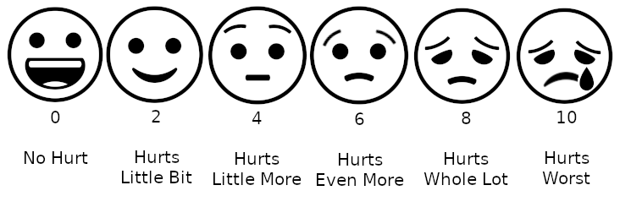

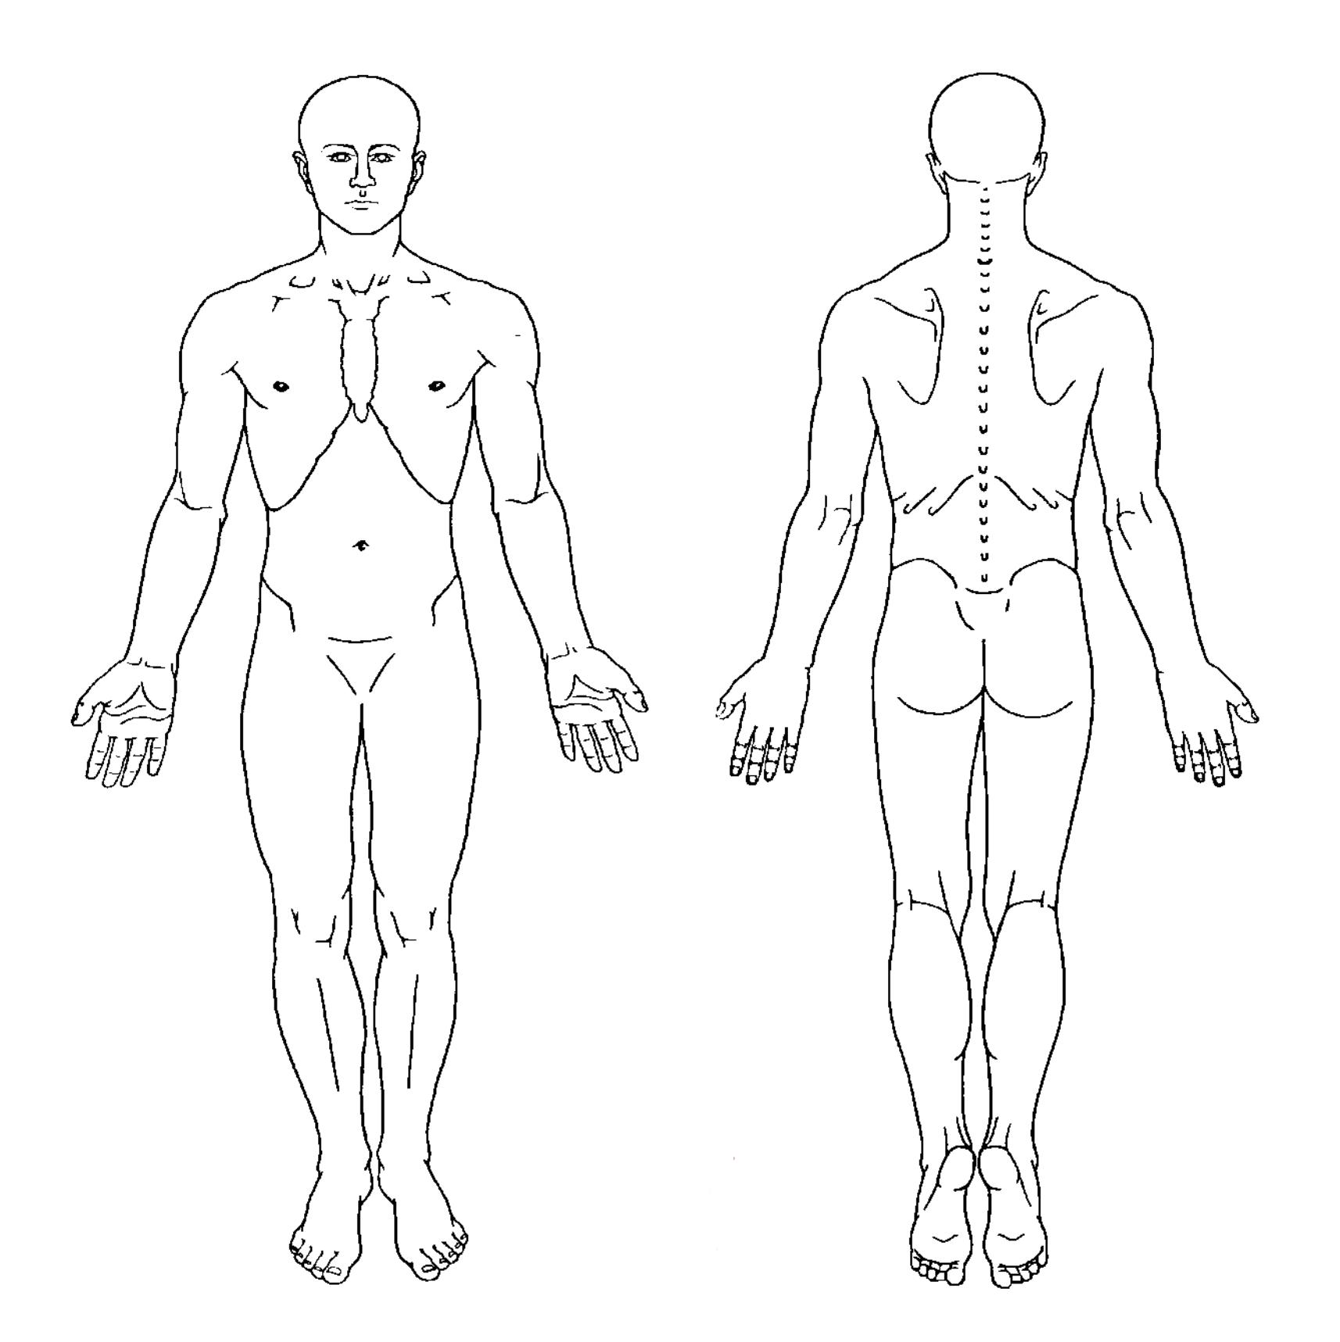

LOCATION OF YOUR PAIN:

In the picture color in **all** your areas of pain. Associated with (check all that apply):

____ Numbness/Tingling

Front Back ____ Night Pain 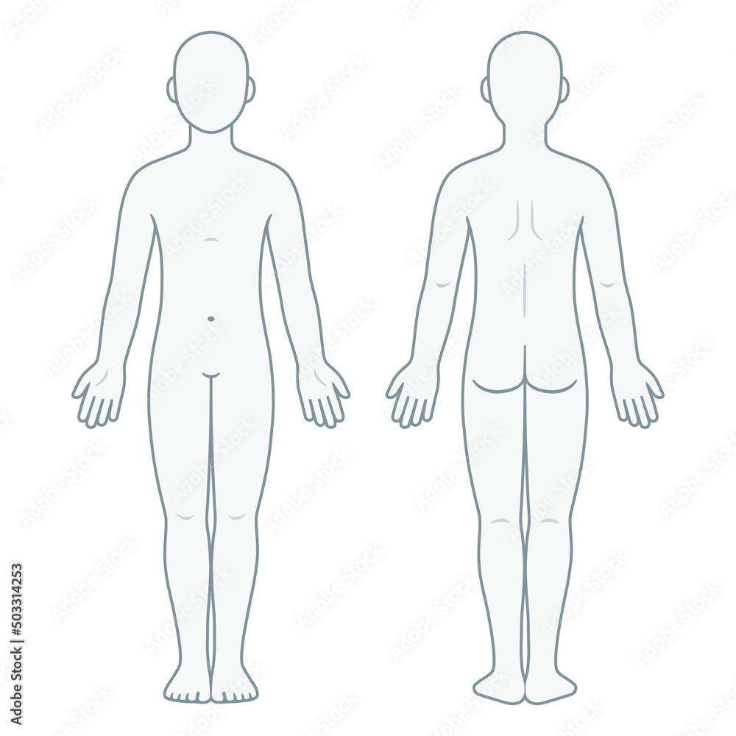

____ Weakness

____ Loss of bowel control

____ Loss of bladder control

____ Fever/Chills

____ Unexplained weight loss

If so, how many pounds? _____

Right Left

Left Right

**Family History:**

Do any illnesses occur frequently in your family?

Illness: Whom?

________________ _______________________

________________ _______________________

________________ _______________________

________________ _______________________

Review of Systems (ROS) - Please check all that apply:

* Weight Loss
* Fatigue
* Appetite Loss
* Contacts/Glasses
* Recent Vision Changes
* High Blood Pressure
* Heart Attack
* Swelling? Where__________
* Shortness of Breath
* Asthma
* COPD
* Sleep Apnea
* Nausea or Vomiting
* Diarrhea
* Constipation
* Bloating
* Acid Reflux
* Blood in Urine
* Kidney Stones
* Difficulty in Urination
* Blackouts
* Stroke
* Seizures
* Headaches
* In-coordination
* Memory Loss
* Muscle Cramps
* Muscle Twitches
* Joint Swelling
* Abnormal Joints
* Muscle Wasting
* Muscle Weakness
* Muscle Pain/Tenderness
* Night Cramps
* Posture Abnormalities
* Depression
* Anxiety
* Sleeping Difficulties
* Bleeding Disorder
* Anemia
* Easy Bruising
* Thyroid Problem
* Diabetes - Type I or Type II
* Polyuria

**Women:**

* Menstrual Abnormalities

____________________________________________________________________________

Pain Management Agreement:

The purpose of the agreement is to prevent misunderstanding about certain medicines you will be taking for pain management. This is to help your doctor comply with the law regarding controlled pharmaceuticals.

I wish to enter a treatment agreement to prevent possible chemical dependency. I understand that if I break this agreement, my doctor will stop prescribing these controlled medications. The doctor may terminate the patient physician relationship if I have made a misrepresentation or false statements concerning my pain or my compliance with this agreement or any other disagreement that my doctor may have with me.

Please initial each line below.

____All new patients will submit to a urine drug screen.

____There will be random urine drug substance screens. I will submit if called upon for a random urine test within 24 hours of the call.

____I will not share, sell, or trade my medication(s) with anyone.

____I will not attempt to obtain any controlled medicines, including opioid pain medications, or controlled stimulants from any other doctor.

____I will take my medications as prescribed by my physician. There will be NO EARLY REFILLS.

____I will be responsible for making sure that I do not run out of my medication on the weekends/holidays. There will be NO after hour coverage to authorize medication refills.

____I will keep my scheduled appointment unless I give a notice 24 hours in advance.

____I will safeguard my pain medication(s) from loss or theft. Lost or stolen medications cannot and will not be replaced.

____Original containers of medication should be brought in to each office visit.

____I fully understand the risks and benefits of the controlled medicines and will also discuss any interaction of my medications with the pharmacist.

____I will notify Chenal Pain Management should I visit the ER.

____I will be discharged from Chenal Pain Management should I test positive for illicit drugs.

I agree to use ____________________________________ pharmacy, located at ___________________

__________________________ and their phone number is ______________________.

I authorize the doctor and my pharmacy to cooperate fully with any city, state, or federal law enforcement agency, including this state’s board pharmacy, in the investigation of any possible misuse, sale or other diversion of my pain medication(s). I authorize my doctor to provide a copy of this agreement to my pharmacy. I agree to waive any applicable privilege or right of privacy of confidentiality with respect to authorizations.

Signature:________________________________________________Date: ______________